# Lab 09b - Implement Azure Container Instances

Made by Valeriy Manuilyk <3

## Task 1: Deploy an Azure Container Instance using a Docker image

1.Sign in to the ****Azure portal**** - https://portal.azure.com.



2.In the Azure portal, search for and select Container instances and then, on the ****Container instances**** blade, click ****+ Create****.

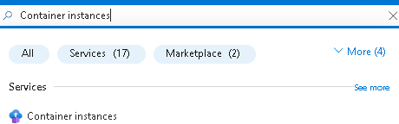

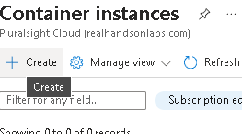

3.On the ****Basics**** tab of the ****Create container instance**** blade, specify the following settings (leave others with their default values):

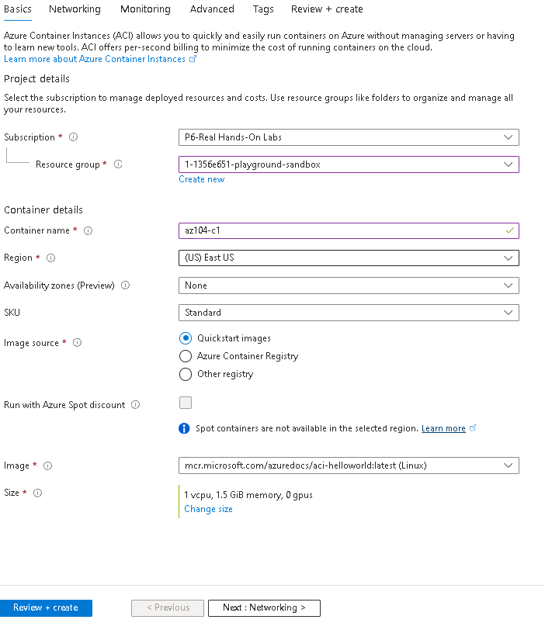

1. Click ****Next: Networking >**** and specify the following settings (leave others with their default values):

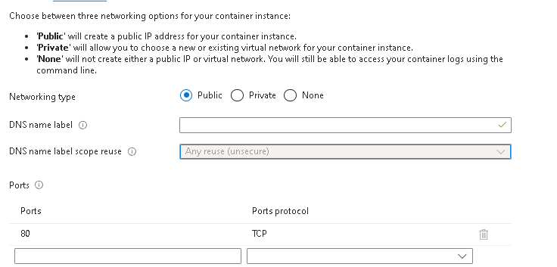

5.Click ****Next: Advanced >****, review the settings without making any changes.

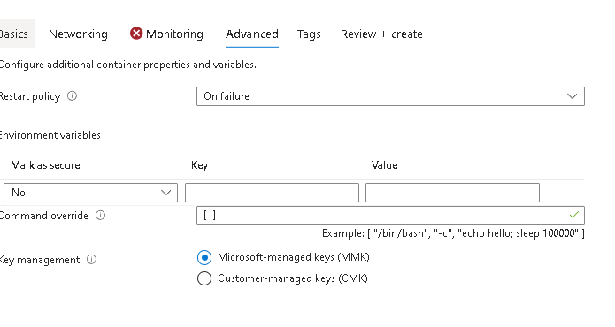

6.Click ****Review + Create****, ensure that the validation passed and then select ****Create****.

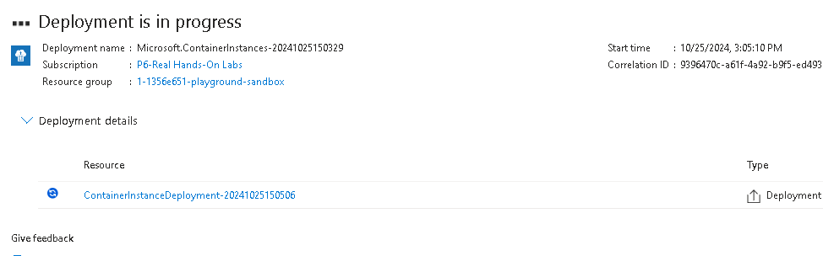

## Task 2: Test and verify deployment of an Azure Container Instance

1.On the deployment blade, click the ****Go to resource**** link.

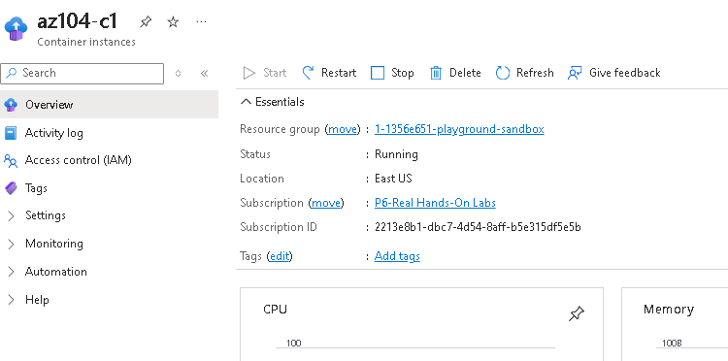

2.On the ****Overview**** blade of the container instance, verify that ****Status**** is reported as ****Running****.

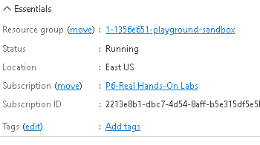

3.Copy the value of the container instance ****FQDN****, open a new browser tab, and navigate to the corresponding URL.

4.Verify that the ****Welcome to Azure Container Instance**** page is displayed. Refresh the page several times to create some log entries then close the browser tab.

5.In the ****Settings**** section of the container instance blade, click ****Containers****, and then click ****Logs****.

6.Verify that you see the log entries representing the HTTP GET request generated by displaying the application in the browser.

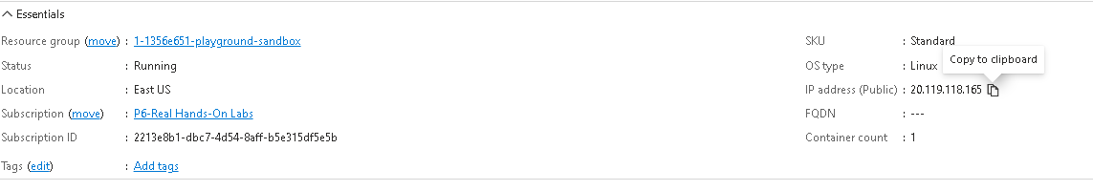

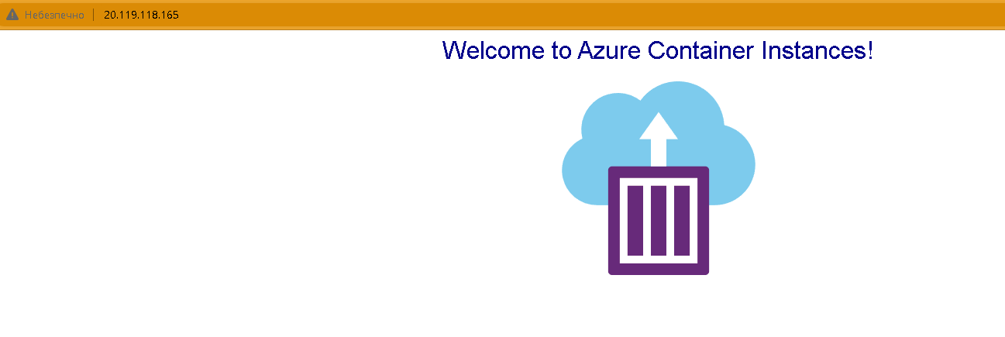

**Conclusion:**

Azure Container Instances (ACI) is a service that enables you to deploy containers on the Microsoft Azure public cloud.

ACI doesn’t require you to provision or manage any underlying infrastructure.

ACI supports both Linux containers and Windows containers.

Workloads on ACI are usually started and stopped by some kind of process or trigger and are usually short-lived.